Секция: английский язык

Тема: «Английские и русские десерты (English and Russian desserts)»
Автор проекта: Беляева Кристина Александровна, учитель английского языка МАОУ ИЭЛ им. А. Гараничева г. Новосибирска

Проект: «Английские и русские десерты»
- 6 класс
- Предметная область: английский язык
- Время работы над проектом: сентябрь 2025 г. – февраль 2026 г.
- Тема проекта: посвящена английским и русским десертам.
- Цель проекта: создание памятки-рецепта десертов (блинов и оладий) для школьников.
Задачи:
1. Изучить особенности и историю десертов в Англии и России.
2. Выбрать рецепты двух похожих десертов в Англии и России (блинов и оладий).
3. Приготовить и сравнить их.
4. Создайте памятку-рецепт этих десертов (блинов и оладий) для школьников.
- Тип проекта (по виду деятельности): поисковый, исследовательский, творческий.
- Используемые технологии: мультимедиа.
11. Форма продукта проекта: памятка-рецепт десертов (блинов и оладий) для школьников.
12. Область применения результата проекта:
- учебная (уроки английского, биологии, технологии, ЗОЖ);
- внеклассная работа (сравнение и приготовление традиционных десертов Англии и России на стендах в школе, в кабинетах, классный час, РОВ, летний пришкольный лагерь).
13. Результативность:
- составлена памятка - рецепт десертов (блинов и оладий) для школьников;
- проводится внеклассная работа в классах;
- развешаны памятки на стендах лицея, в кабинетах.

CONTENT

Passport……………………………………………………………………………..2
Introduction...............................................................................................................3
Chapter 1. The theoretical part.
  - History of English desserts..............................................................................4
  - Popular English desserts………......................................................................4
  - History of Russian desserts……………………………………………….….6
  - Popular Russian desserts…………………………………………………….6
Chapter 2. The practical part.
2.1. Survey.................................................................................................................8
2.2. Making desserts in England and Russia (pancakes and blini)....…...….............8
2.3. Creating a mini recipe leaflet (pancakes and blini)……………………..…......8
Conclusion.................................................................................................................9
List of sources used ................................................................................................10
Appendix 1..............................................................................................................11
Appendix 2..............................................................................................................12
Appendix 3..............................................................................................................15
Appendix 4..............................................................................................................18
Appendix 5 .............................................................................................................19
Appendix 6 .............................................................................................................20
Appendix 7………………………………………………..………………………22

Introduction
The topic of the project is devoted to English and Russian desserts. This topic has a linguistic and cultural nature, allowing us to learn in detail about the traditional sweet dishes of England, the country of the language we are studying, and Russia, the country whose native speakers we are.
A dessert is a sweet dish served after the main course (and not as the main course), at the end of a meal. The term is borrowed from the French language dessert, from the French «desservir», which means "to clear the table."
National cuisine is an important factor in attracting foreign tourists to a country. This is understandable, as culinary art preserves the national characteristics and traditions of a people, which are always interesting to a representative of another country.
The relevance - the development of tourism necessitates the study of the dietary habits of different nations. It is important to know their characteristics, history, and how to prepare dishes from their national cuisines, particularly desserts.
The purpose - develop a recipe leaflet for desserts (pancakes and blini) for students.
Tasks:
1. To study the features and history of desserts in England and Russia.
2. To select recipes for two similar desserts in England and Russia (pancakes and blini).
3. To prepare and compare them.
4. Create a recipe leaflet for these desserts (pancakes and blini) for students.
The object of the study - desserts.
The subject of the study - traditional desserts in England and Russia.
Research methods - analysis of the experience of other countries, conducting a survey among the students of my school.

Chapter 1. The theoretical part.
1.1. History of English desserts
In the period from the 11th to the 16th centuries, the Normans introduced a more refined cuisine than the one that existed before them. They brought the traditions of Italian and French cuisines to Britain. Strawberries, cakes, flans, candied fruits, cakes, and cream were served for dessert. The most common type of pastry was bread with honey, spices, raisins, and grapes. At Christmas, accompanied by honey cookies.
Starting from the 16 century there were important changes in British cuisine due to the historical events of those years. It was a period of separation from Catholicism. In 1830, the sweet food trade emerged. Puddings, biscuits, tea, coffee, and famous sandwiches were sold on the streets.
British cuisine is diverse, as each region has its own dishes. As for desserts, there are many of them. It is also important to note the tradition of five o'clock tea, which is traditional for British residents. Of course, not everyone adheres to it now, but there are dishes and, first of all, dessert dishes baked specifically for five o'clock.

1.2. Popular English desserts
- English scones
The first mentions of them date back to the 16th century. The name of the buns speaks of their Scottish origin. The word schoonbrood simply means white bread (schoon - «clean»). Scone is the main and very colorful part of the traditional English tea party. Essentially, these are buns with jam and cream. (Appendix 1)
- Pudding
The word pudding comes from the French «boudin» from the 16th century. When cooking pudding, spices, cereals, and prunes were added, and sugar began to be added in the late 18th century. Pudding became sweet and evolved into a dessert.
Traditionally, they are served at Christmas. The famous dessert is a jelly-like cake made in a water bath using a mixture of flour, eggs, milk, and sugar, with the addition of berries and fruits. The cooled pudding is covered with liquid chocolate, jam, or butter-based cream. (Appendix 1)
- Trifle
Trifle – in translation from English "a trifle" or "a trifle", which speaks of the simplicity of the preparation of the dish. Trifle has a long history. The English consider this dessert to be their national dish, which is already more than 300 years old. The first recipe for English trifle appeared back in 1596. Then the dessert consisted of cream with the addition of sugar, ginger and rose water.
Today, trifle consists of sponge cake dough, custard and fruit. The main feature of the Trifle dessert is that it is created in transparent dishes so that the layers are visible, using colorful fruits and berries, and various fillers. (Appendix 1)
- Banoffee
Banoffee (English Banoffee pie) is one of the most popular English desserts. It is an English pie made from bananas, cream, caramel and boiled condensed milk. The basis for banoffi is prepared from crushed biscuits with the addition of butter. The name of the dessert comes from the fusion of two words: "banana" and "toffee" (caramel). The authors of the pie are Nigel Mackenzie and Ian Dowding from 1971. (Appendix 1)
- Pancake
Pancake has a long history in England. Pancakes first appeared in cooking books in the 1400s. The tradition of "pancake racing" originated in the town of Olney in Buckinghamshire in 1445.
Pancakes are part of the Pancake Day (Shrove Tuesday) celebration, a traditional holiday day before the beginning of Lent (40 days before Easter). Pancakes are a way to use eggs and fats before the start of lent, as Christians usually confessed and "cleansed" of sins on this day. In the UK, pancake runs are an important part of Pancake Day celebrations, where people, often in festive dress, run through the streets tossing pancakes. (Appendix 1)
- Queen Victoria Sponge cake
Queen Victoria Sponge cake is one of the most impressive sweets in England. It is also called Victoria Sponge Sandwich. You can try it in the form of a cake or brownie. Delicate sponge cakes with air cream are complemented by a delicious and fragrant puree of fresh strawberries or raspberries. The Victoria Sponge dessert was named after Queen Victoria of England, who loved this delicacy with a cup of hot afternoon tea. (Appendix 1)

1.3. History of Russian desserts
In Russia the term "dessert" gets in the 17th century. Before that, the dessert was called "zaedki", but with the advent of the term "snacks", "zaedki" began to be called "dessert".
Traditional Russian desserts are a variety of baked dishes. Our ancestors baked apples, pears and other fruits and berries in the oven with honey to improve the taste, placing them in a cast iron pot. Some housewives dried carrots and beets in the oven, cut into small pieces — this dish called "parenki".
Russian desserts from forest and garden berries: viburnum, rowan, raspberry, currant. The resulting product was like a pastille and were known as "zaedki". They were used in the treatment of colds, especially in the cold season. As a dessert, a thick compote could be served on the table — "uzvar" or "vzvar", and fool. The thick hot drinks had a sweet taste and a pleasant consistency.

1.4. Popular Russian desserts
1. Gingerbread
The first gingerbread cookies were baked by the Egyptians. They baked flat cakes and smeared them with honey. In Russian gingerbread, honey is added to the dough itself. In Russia, the first gingerbread appeared at the beginning of the ninth century and was called "honey bread". Honey breads were baked from a mixture of rye flour, honey, berry puree or juice.
The name "gingerbread" appeared much later. It comes from the word "spicy" because ginger, allspice and other spices used to be put in gingerbread. Their recipes were kept strictly secret, so each area had its own unique varieties of this delicacy. (Appendix 2)
- Pastille
Pastila, a national dessert made from apples and honey, appeared back in the 14th century. The delicacy was made from sour apples, mixed with currants, mountain ash, cranberries and honey, and sugar was introduced at the beginning of the 19th century. To give the dessert a light color and density, whipped egg white was used. (Appendix 2)
- Candied fruits ("balabushki")
Candied fruits in Russia were called Kievan dry jam, or "balabushki", in honor of the Kiev merchant Semyon Semenovich Balabukha. He first opened a jam production shop, and then a candy store in the center of Kiev. For the first time, such jam was brought from Kiev to the wedding of Prince Jagiello in 1386.
Catherine the Great adored this delicacy and even issued a special decree according to which dry jam from berries, fruits, and wild rose was to be delivered to the court annually. (Appendix 2)
- Milk shavings
Ice cream in Russia was also unusual — dairy stroganina. The milk was frozen, then ground and served with hot pancakes. Under Paul I, real ice cream appeared in St. Petersburg and Moscow. The progenitor of this delicacy, finely ground frozen milk, was served in Russia with hot pancakes. Catherine the Great and Peter III were big fans of dairy stroganina. (Appendix 2)
- Pancakes (blini)
The first information about pancakes (blini) in Russia dates back to the 9th century. The word "pancake" comes from the Old Russian "mlin", associated with the verb "grind" and denoting a product made from ground grain. In ancient Russian houses, the preparation of blini was a ritual: the housewives kneaded the dough in the evening, often by moonlight, pronouncing special spells.
The secrets of making dough have been passed down from generation to generation, often exclusively through the female line. There were many toppings for blini in Russia: they were eaten with sour cream, honey, cottage cheese, jam, meat or fish, mushrooms, berries, eggs. (Appendix 2)
- Siberian shanties
Shanezhka, shanga is a Russian dish, an open pie, and flatbreads made from dough. It is well baked in a Russian oven or oven. The Russian population borrowed the name from the aboriginal Finnish tribes. Today, shangi is made with mashed potatoes or cottage cheese. (Appendix 2)

Chapter 2. The practical part
2.1 Survey
After studying the history and features of English and Russian desserts, I conducted a survey in 5-11 grades. 96 students took part. (Appendix 3, 4) Then I started the next stage of work.

2.2 Making desserts in England and Russia (pancakes and blini)
I chose recipes for two similar desserts from different countries (pancakes and blini) and cooked them. I brought them to my classmates in English class to taste. Many students liked both desserts, but most of them had never cooked pancakes at home before, so they asked for the recipe. (Appendix 5, 6)

2.3 Creating a mini recipe leaflet (pancakes and blini).
I made a recipe leaflet for self-cooking by students at home. (Appendix 7)

Conclusion
While working on the project, we found out that desserts are a traditional addition to any menu of both Russian and English cuisine. Dinners end with desserts, they are the decoration and completion of the festive table.
When we got acquainted with the names of desserts, we learned a lot of previously unknown Russian and English words (scones, custard, balabushki, trifle, bannoffi). After analyzing the meanings of dessert names, we found out that most of these words in both Russian and English are indeed related to cooking technology (Trifle, ice cream, pancakes, jelly, pastille), ingredients (Bannock, gingerbread), and the names of famous people (Battenberg, Queen Victoria Sponge Cake). Some of the names came from the area where the dessert was first created (scones, shanties).
After studying the traditional classic desserts of the British and Russians, we chose two dishes similar in recipe and preparation (pancakes and blini) and made a mini recipe leaflet that will be a good helper when cooking these dishes ourselves for students at home.

List of literature
- Dickson Wright K. The history of English cuisine // K. Dickson Wright. – M.: Cookbooks, 2011. – 574 p.
- James Martin. Desserts a Fabulous Collection of Recipes // James Martin. – M.: Cookbooks, 2013. – 192 p.
- Josh Eggleton England, England. Gastronomic journey //Josh Eggleton, Moscow: Your Book, 2014, 247 p.
- Molokhovets E. Pies and pies. Sweet and salty. // E. Molokhovets– Moscow: Eksmo, 2019, 58 p.
- Piskunov V. Russian cuisine. The best in 500 years. The second book. // V. piskunov. – M.: KhlebSol, 2019. – 218 p.
- Rufanova E.V. The whole collection of "Encore recipes" // E.V. Rufanova. – M.: Gazetny Mir, 2018. – 79 p.
- How did sweets come about? The evolution of desserts. [Electronic resource] URL: https://www.shkolazhizni.ru/meal/articles/110047/.
- The history of desserts. Interesting facts about delicious food. [Electronic resource] URL: http://drprof.r u/pitanie/istoriya-vozniknoveniya-desertov.h
- The history of sweets. [Electronic resource] URL: https://sladrus.ru/poleznaya-informatsiya/istoriya-vozniknoveniya-sladostej/.
- The history of desserts. [Electronic resource] URL: https://kedem.ru/history/istoriya-desertov/.
- The History of desserts: from ancient times to the present. [Electronic resource] URL: https://dzen.ru/a/Z-QTivr2qlVGaOki.
- Traditionally Russian and incredibly delicious desserts. [Electronic resource] URL:http://shnyagi.net/49807-tradicionno-russkie-i-neveroyatno-vkusnyedeserty.

Appendix 1
Popular English desserts
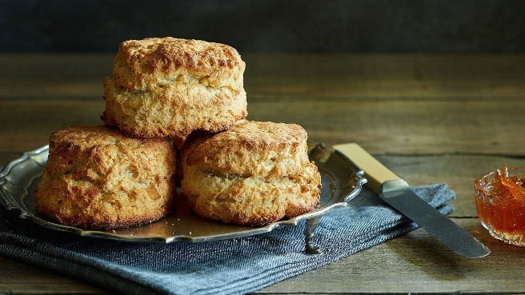 1. English scones (Английские сконы)

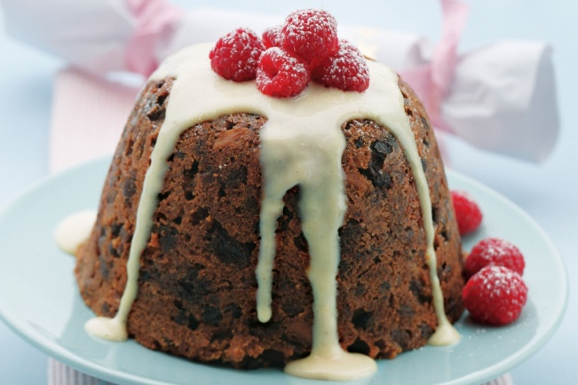 2. Pudding (Пудинг)

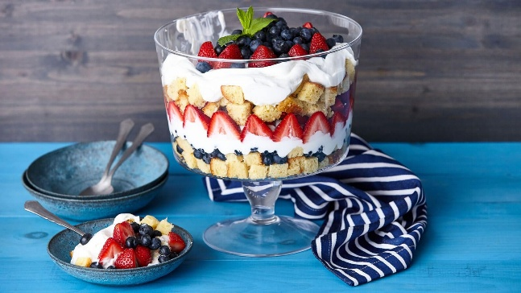 3. Trifle (Трайфл)

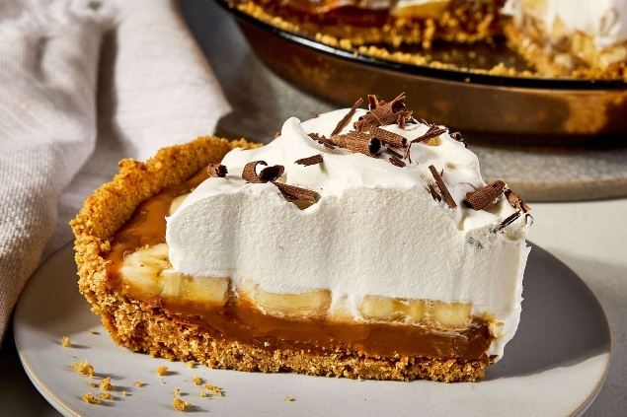 Banoffee (Баннофи)
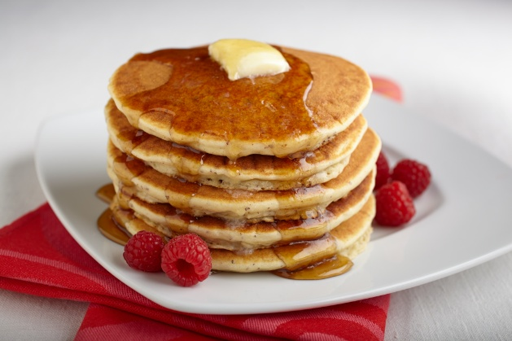 Pancake (Панкейк)

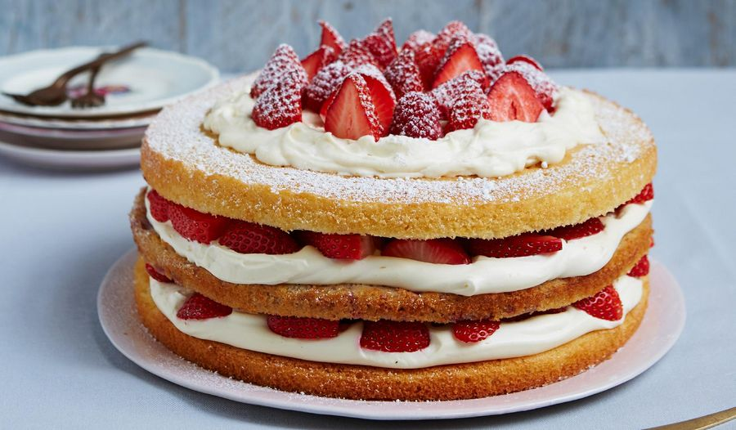
Queen Victoria Sponge cake (Бисквит королевы Виктории)

Appendix 2
Popular Russian desserts
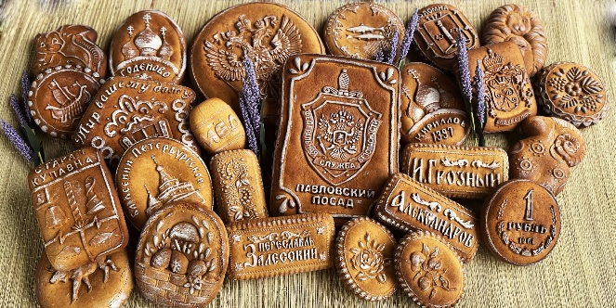 Gingerbread (Пряник)

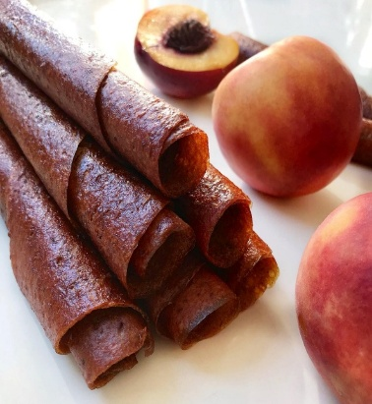 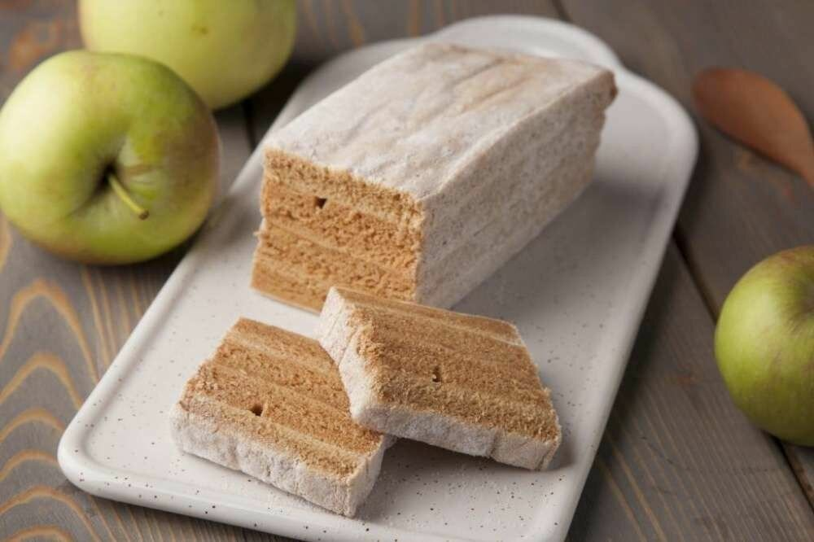 Pastille (Пастила)

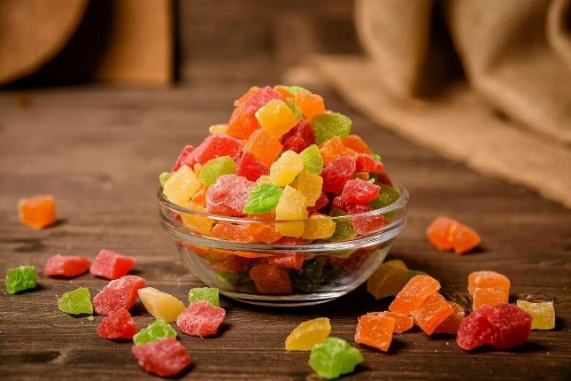
Candied fruits ("balabushki") – Цукаты («балабушки»)

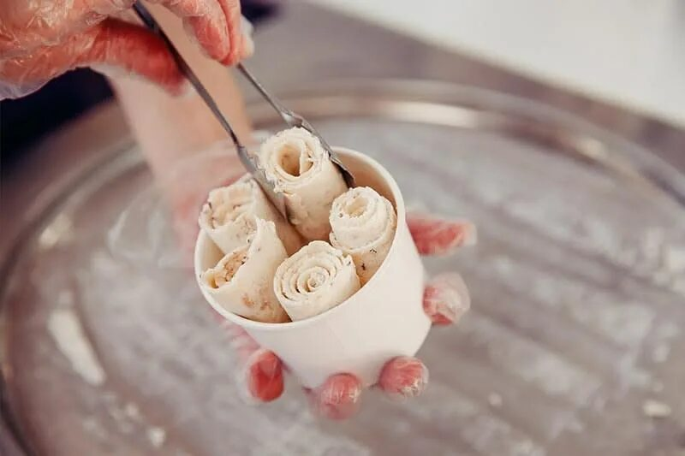 Milk shavings (Стружка из молока)

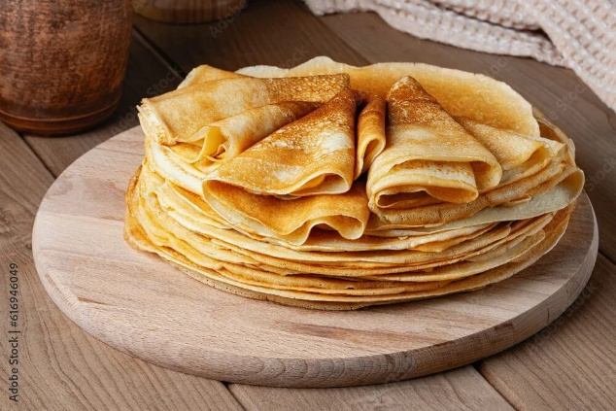 Blini (Блины)

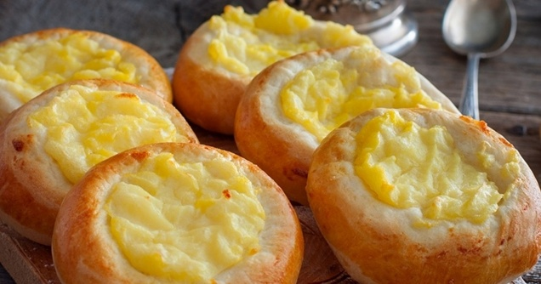 Siberian shanties (Сибирские шанежки)

Appendix 3
Questionary
1. What desserts do you know from Russian cuisine?

2. Which ones are your favorites?
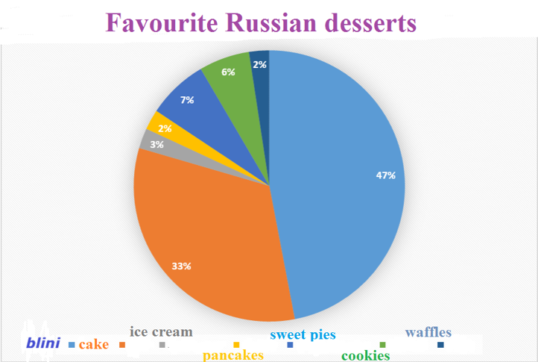
3. What desserts do you know from English cuisine?

4. Which ones do you like?
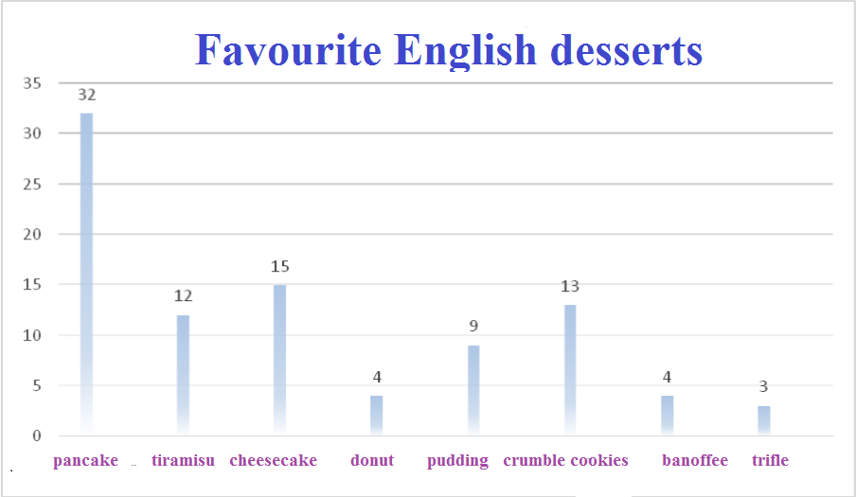
- What desserts do you make at home?

- Do you make blini at home? What do you eat them with?
Filling | Number of people
Condensed milk | 29
Sour cream | 28
Jam | 26
Caviar | 3
Meat | 4
Cheese | 3
Cottage cheese | 2
Honey | 2

7. Do you make pancakes at home? What do you eat them with?
Filling | Number of people
Honey | 3
Berries and fruits. | 7
Condensed milk | 15
Jam | 17
Chocolate spread | 17
Sour cream | 2
Ice cream | 3

Appendix 4

The survey process
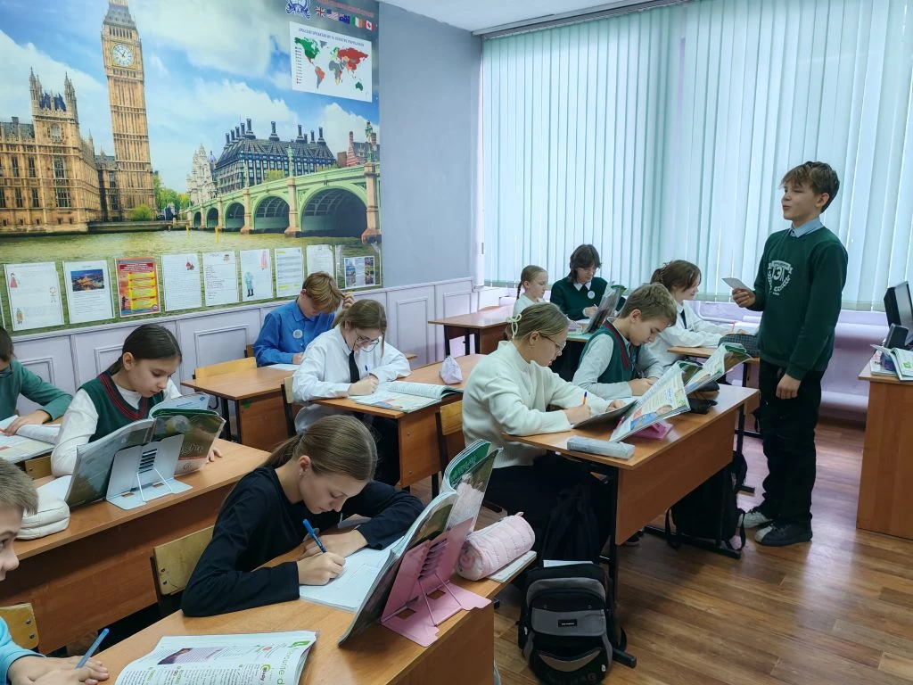
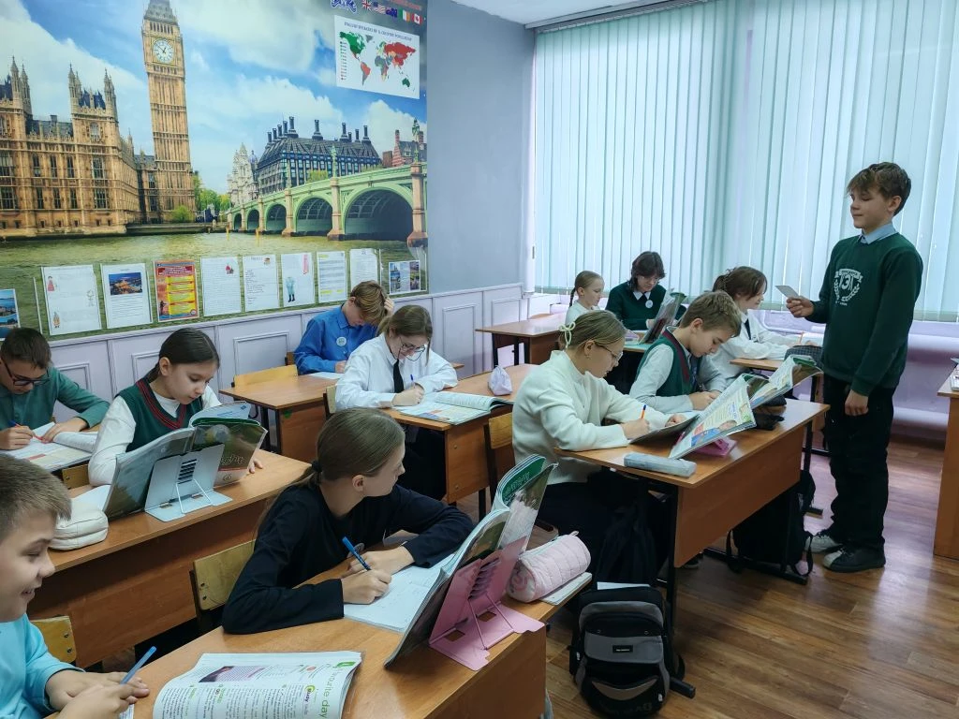
Appendix 5
Recipe «Pancake»
- 2 eggs
- 3 teaspoons of sugar
- 200 ml of milk
- 180 g flour
- 10 g baking powder
- 3 tablespoons sunflower oil

Break two eggs, add 3 teaspoons of sugar and mix. After that, add 200 ml of milk and mix again. Pour 180 g of flour with 10 g of baking powder, add 3 tablespoons of oil.

Recipe «Blini»
- 3 eggs
- 30 g of sugar
- 1/2 teaspoon salt
- 150 ml milk
- 200 g flour
- 350 ml milk
- 3 tablespoons sunflower oil

Break three eggs, add 30 grams of sugar and 1/2 teaspoon of salt, mix. After that, add 150 ml of milk and mix again. Add 200 g of flour, then pour 350 ml of milk, add 3 tablespoons of oil.

Appendix 6
Blini
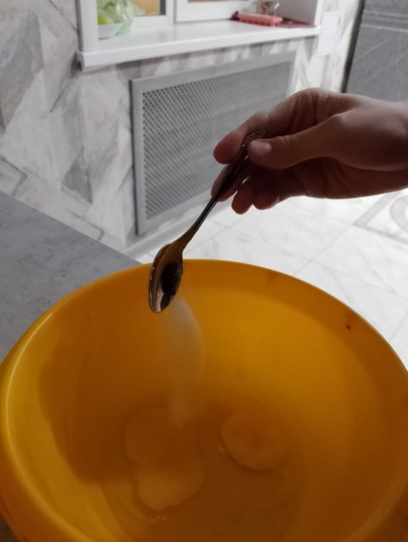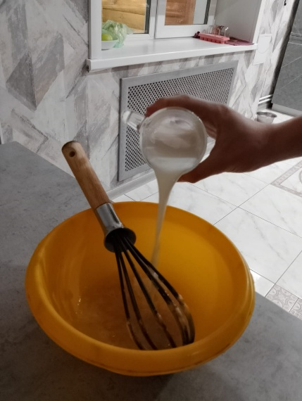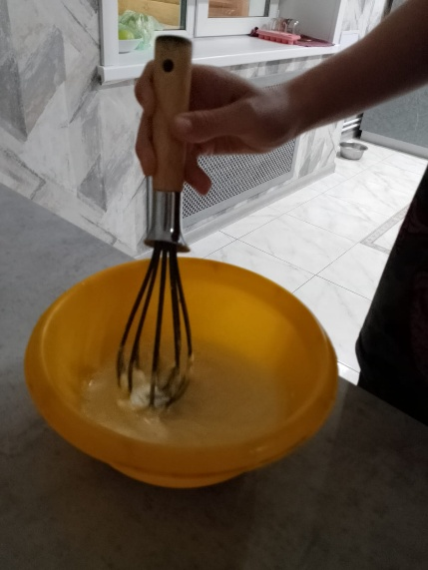
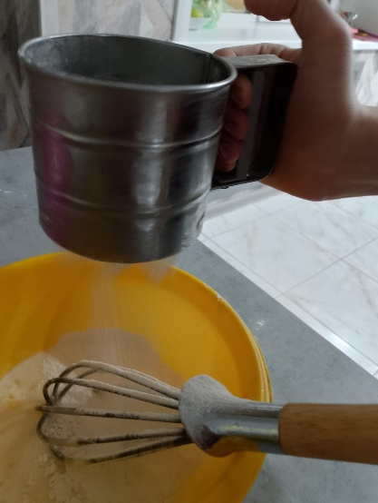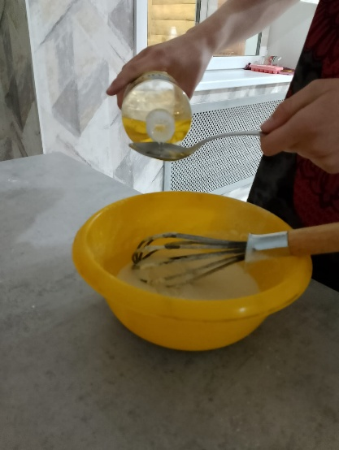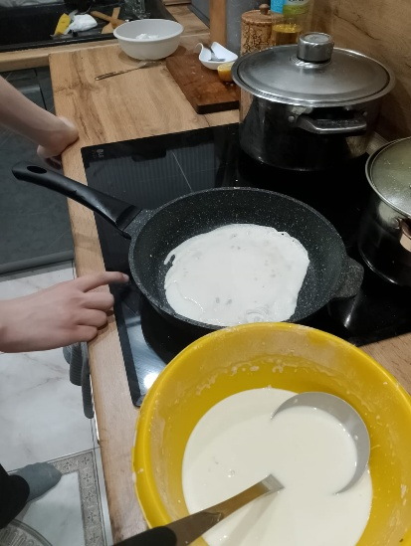
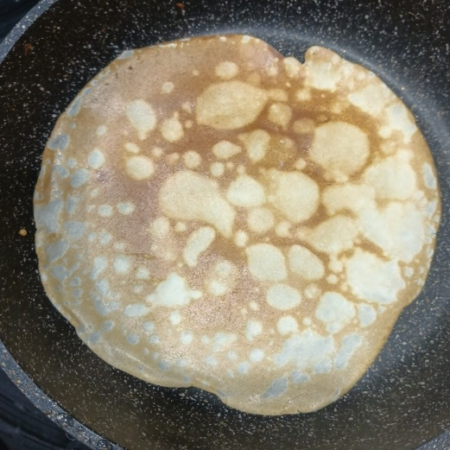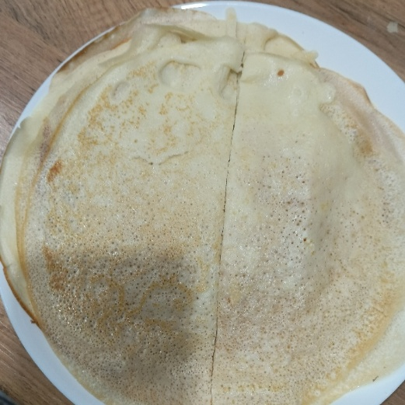

Pancake
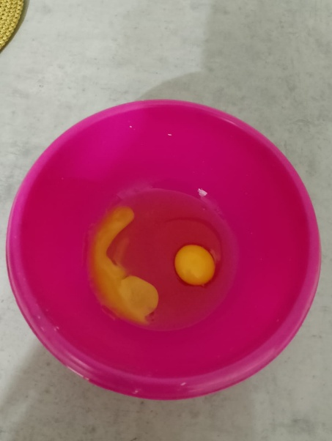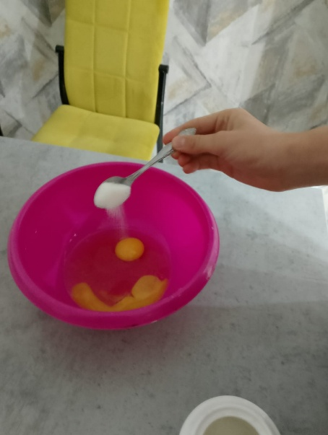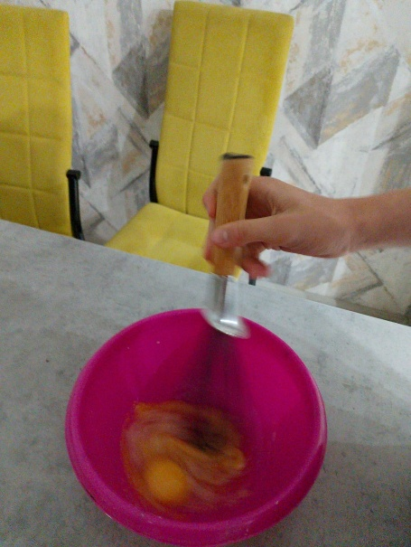
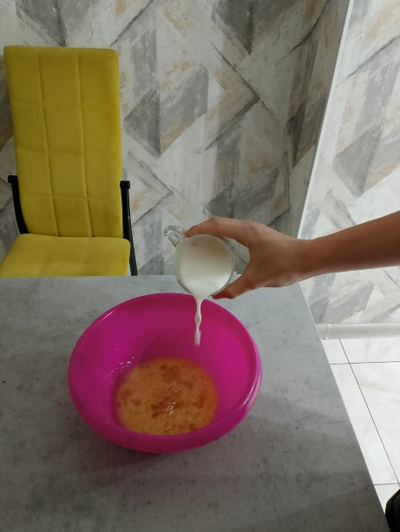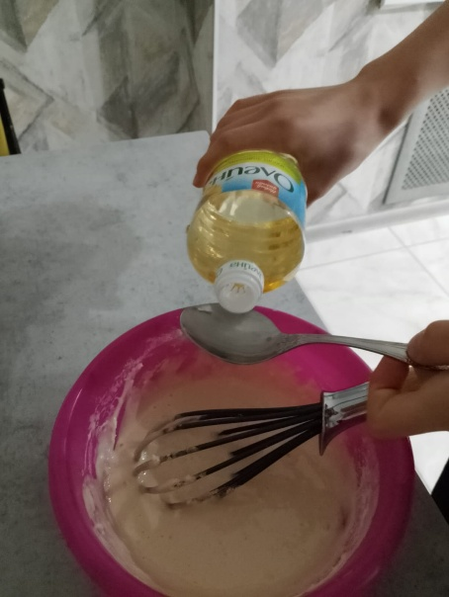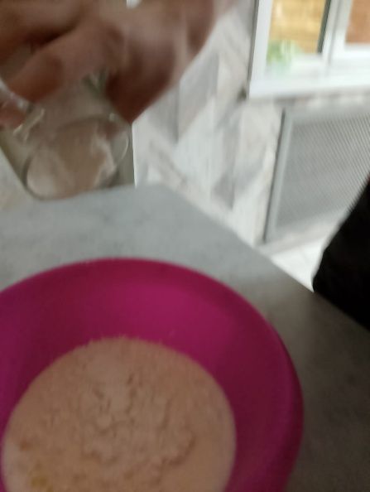
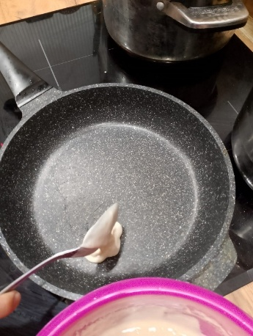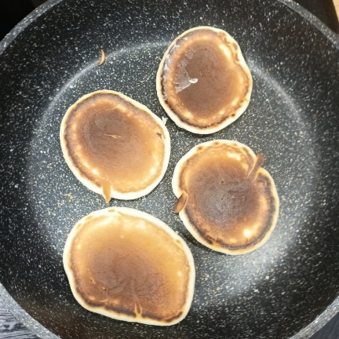

After the students tasted the ready-made pancakes and pancakes in class, many classmates liked both desserts. But most of them had never cooked pancakes at home before, so they asked for the recipe.

Appendix 7
Mini recipe leaflet (pancakes and blini) for self-cooking by students at home


