ОБУЧЕНИЕ ИНОЯЗЫЧНОМУ ЧТЕНИЮ КАК СРЕДСТВУ ОВЛАДЕНИЯ СИСТЕМОЙ НАВЫКОВ НА СРЕДНЕЙ СТУПЕНИ ОБЩЕОБРАЗОВАТЕЛЬНОЙ ШКОЛЫ НА ПРИМЕРЕ СКАЗОК ОСКАРА УАЙЛЬДА

Автор работы:
Учитель иностранных языков
МБОУ «Халдеевская ООШ» Томского района
Эбингардт Юлия Тимуровна

Формирование навыков иноязычного чтения – одна из основополагающих задач в обучении иностранному языку. Благодаря чтению учащиеся получают возможность овладевать всеми аспектами языка, а именно фонетикой, лексикой, грамматикой, а также постигать глубины культуры и мироощущения людей, говорящих на этом языке.
Одним из основных средств формирования навыков эффективного чтения выступают художественные произведения. Природа литературных творений заключается в их многогранности и богатом языковом и смысловом наполнении. Более того, литературный язык являет собой образец эталонной речи, поэтому художественные произведения учат правильно и красиво выражать мысли на изучаемом языке, а также помогают обогатить речь выразительными и изобразительными средствами, делающими речь яркой и образной.
Средний этап обучения иностранному языку в школе – время, когда учащимся могут быть предложены несложные аутентичные произведения выдающихся авторов страны изучаемого языка. Для данной работы были отобраны сказки британского писателя Оскара Уайльда, сюжеты, мораль и изобразительные харктеристики которых вызывают большой интерес у читалетей уже многие годы.
На основании отобранных сказок, а именно “The Nightingale and The Rose” (рус. Соловей и роза), “The Devoted Friend” (рус. Преданный друг), “The Happy Prince” (рус. Счастливый принц), были разработаны упражнения, цель которых – обеспечить учащимся условия для эффективного формирования навыков иноязычного чтения и глубокого понимания прочитанного. Большое внимание в упражнениях было уделено выразительным и изобразительным средствам речи, без должного владения которыми невозможно эффективное овладение иностранным языком.
В соответствии с условиями современного иноязычного образования необходимо обратить внимание на то, что процесс развития речевой выразительности должен стать неотъемлемой составляющей занятия по иностранному языку. Это значит, что обучающиеся постоянно должны быть включены в процесс развития речевой выразительности в ходе изучения иностранного языка. Помимо этого в процессе работы над упражнениями необходимо обращать внимание школьников на проблемные нравственно-эстетические ситуации, представленные в сказках. При этом важно, чтобы ученики осознанно подходили к рассмотрению подобных ситуаций, самостоятельно осуществляли поиск возможных решений и обращались к собственному опыту. Также это положительно влияет на развитие мотивации учеников и на проявление большего интереса к изучаемому предмету.

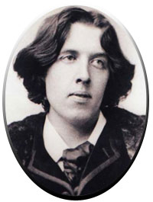
Комплекс упражнений

Oscar Wilde, known for his acerbic and urbane nonfiction, was also a master of fairy tale. While some of his inimitable irony remains, Wilde created lovely tales filled with princes and nightingales mermaids, giants, and kings. In fact, all of his fairy tales are written in an erudite, aesthetic voice. As one of the representatives of Aestheticism, his fairy tales are studied as a model of Aestheticism in terms of style. Wilde showed the particular appeal of language to the readers and made the literature, the art of language, more charming. His fairy tales is characteristic of making use of rhetoric means and ironic humor to convey its theme, such as love or art and the spirit of self-sacrifice as in The Nightingale and the Rose.

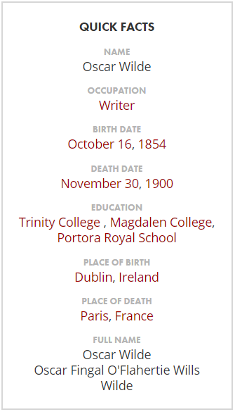

Quote: “Be yourself; everyone else is already taken.”

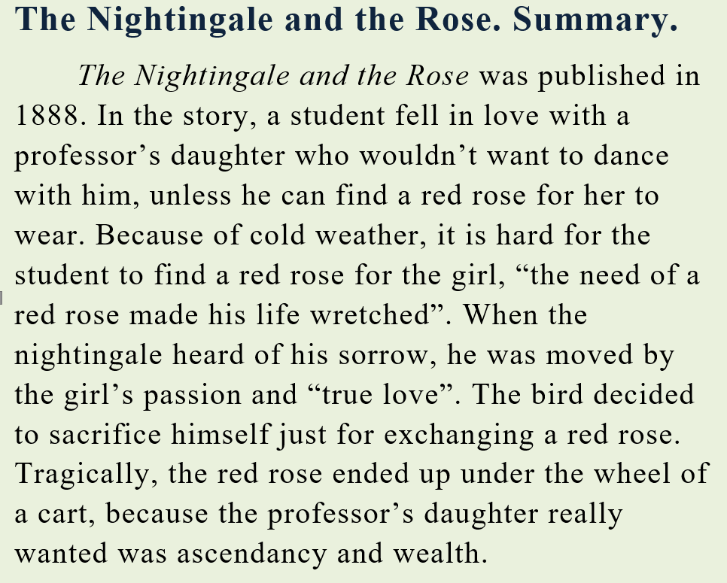

Question: What is the message of the story?
P.S. Oscar Wilde’s fairy tale The Nightingale and the Rose, like other Oscar Wilde’s short stories, is written in an aesthetic voice. During this fairy tale, Oscar Wilde uses various stylistic devices for the interpretation of aesthetic and artistic notions.
P.S. Oscar Wilde’s fairy tale The Nightingale and the Rose, like other Oscar Wilde’s short stories, is written in an aesthetic voice. During this fairy tale, Oscar Wilde uses various stylistic devices for the interpretation of aesthetic and artistic notions.
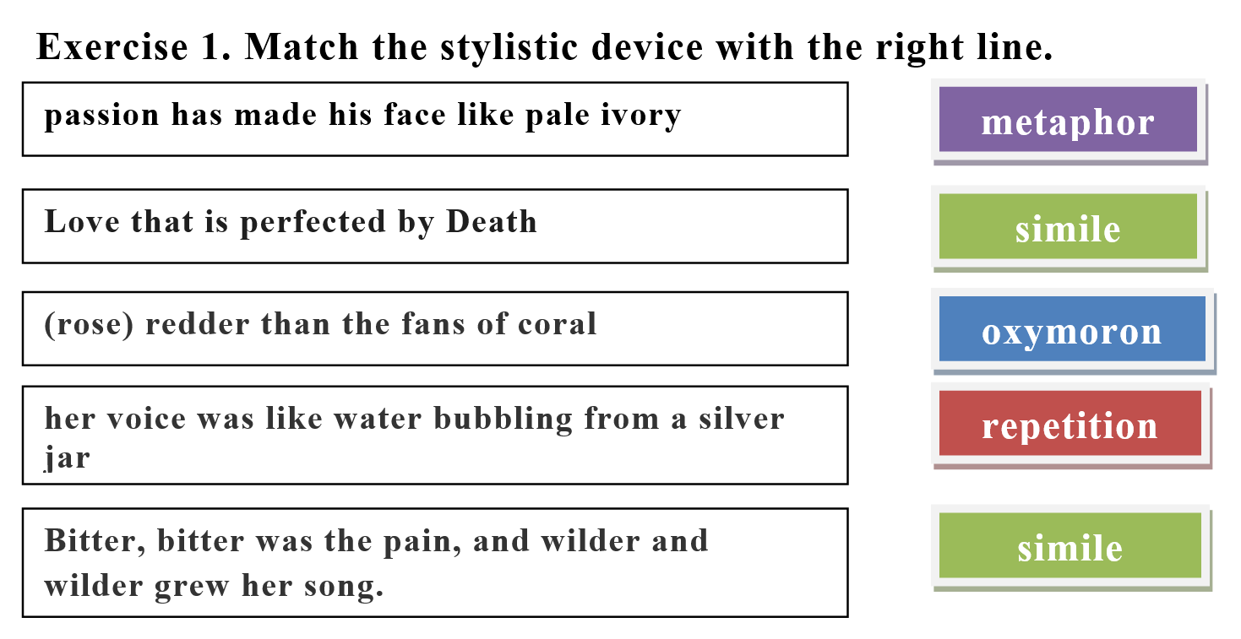

Exercise 2. Find stylistic devices in the abstracts explaining their functions.
(1) …Bitter, bitter was the pain, and wilder and wilder grew her song. And the marvelous rose became crimson. Crimson was the girdle of pedals, and crimson as ruby was the heart. But the Nightingale’s voice grew fainter… Fainter and fainter grew her song…
(2)…'Why is he weeping?' asked a little Green Lizard, as he ran past him with his tail in the air.
'Why, indeed?' said a Butterfly, who was fluttering about after a sunbeam.
'Why, indeed?' whispered a Daisy to his neighbour, in a soft, low voice.
'He is weeping for a red rose,' said the Nightingale.

'For a red rose!' they cried; 'how very ridiculous!' and the little Lizard, who was something of a cynic, laughed outright.
But the Nightingale understood the secret of the Student's sorrow…
(3) …'The musicians will sit in their gallery,' said the young Student, 'and play upon their stringed instruments, and my love will dance to the sound of the harp and the violin. She will dance so lightly that her feet will not touch the floor, and the courtiers in their gay dresses will throng round her…

Exercise 3. Find in the story the right symbol-meaning for each word in the box. Why do you think so?
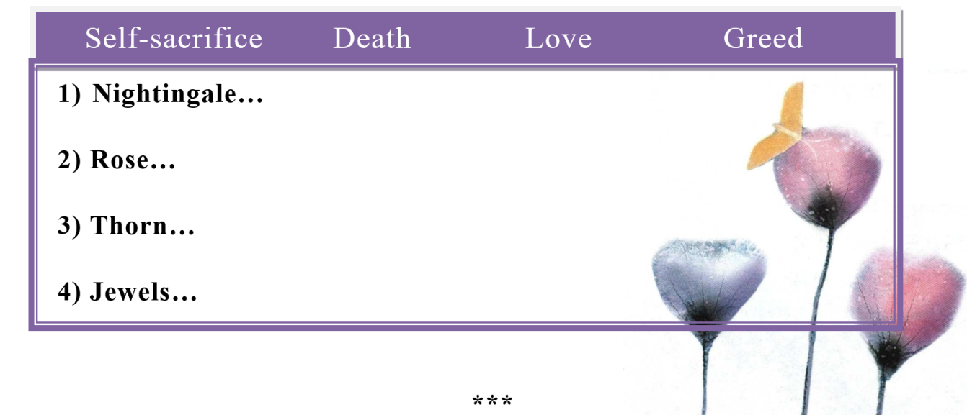
Happy Prince. Summary.
The story of “The Happy Prince” has three major themes, firstly it shows that apparent beauty is nothing and the real beauty is to bestow love and sacrifice. Secondly, it discusses that love and sacrifice are two saving forces. Thirdly, it shows that there is a large gap between rich and poor people the rulers and the masses. When the happy prince is alive he lives a happy life without sorrows, he is living a care free life but after his death he sees through a tall Colum that life has another view except happiness and that is helplessness poverty, hypocrisy and corruption of elite and ruling class. When a bird swallow comes and stays under the feet of prince he begs for his helps match girl, poor writer. He is apparently happy but is weeping bitterly after seeing all the down trodden people. At the end, the swallow dies frost once; the mayor passes through that way and sees prince in ugly plight. They are perplexed to see that the prince has not all the precious stuff on his body now they pulled it down and decide to mark another statue. The statue does not soften in the furnace and workers threw it on the dust heap, the dead body of swallow was also there. An angle comes towards God and takes both precious things which are now of no use for the worldly people but has great importance in eternal life in paradise.

Exercise 4. Find the stylistic devices (metaphor/simile) in the sentences and put them down in the right column. Explane your choice.
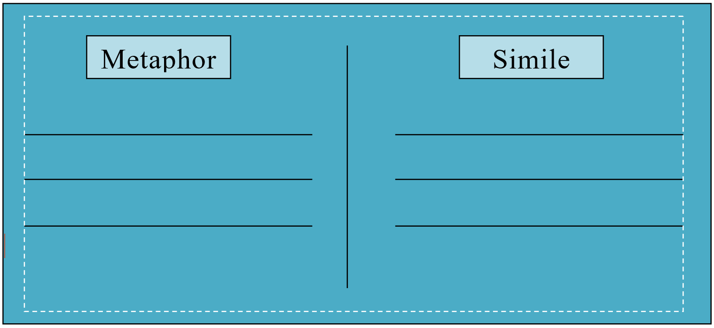
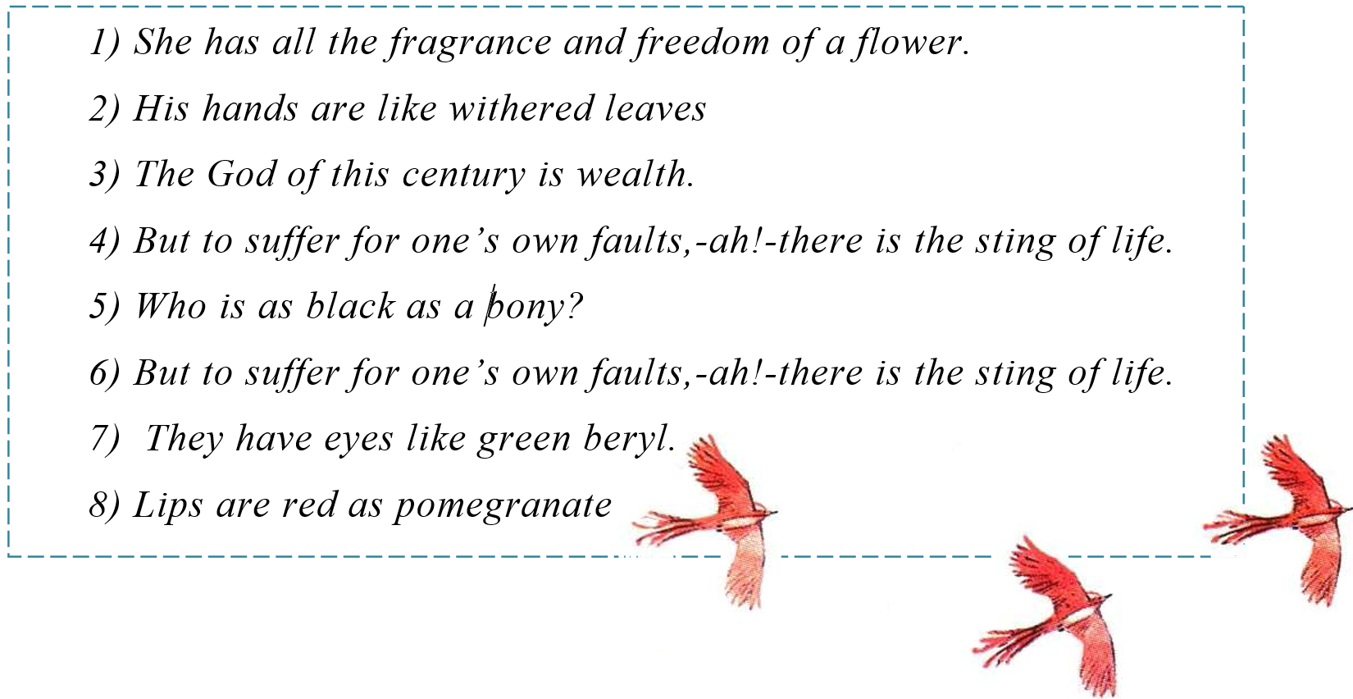
Exercise 5. Find as many stylistic devices in the extract as possible. Translate them and explain their functions.
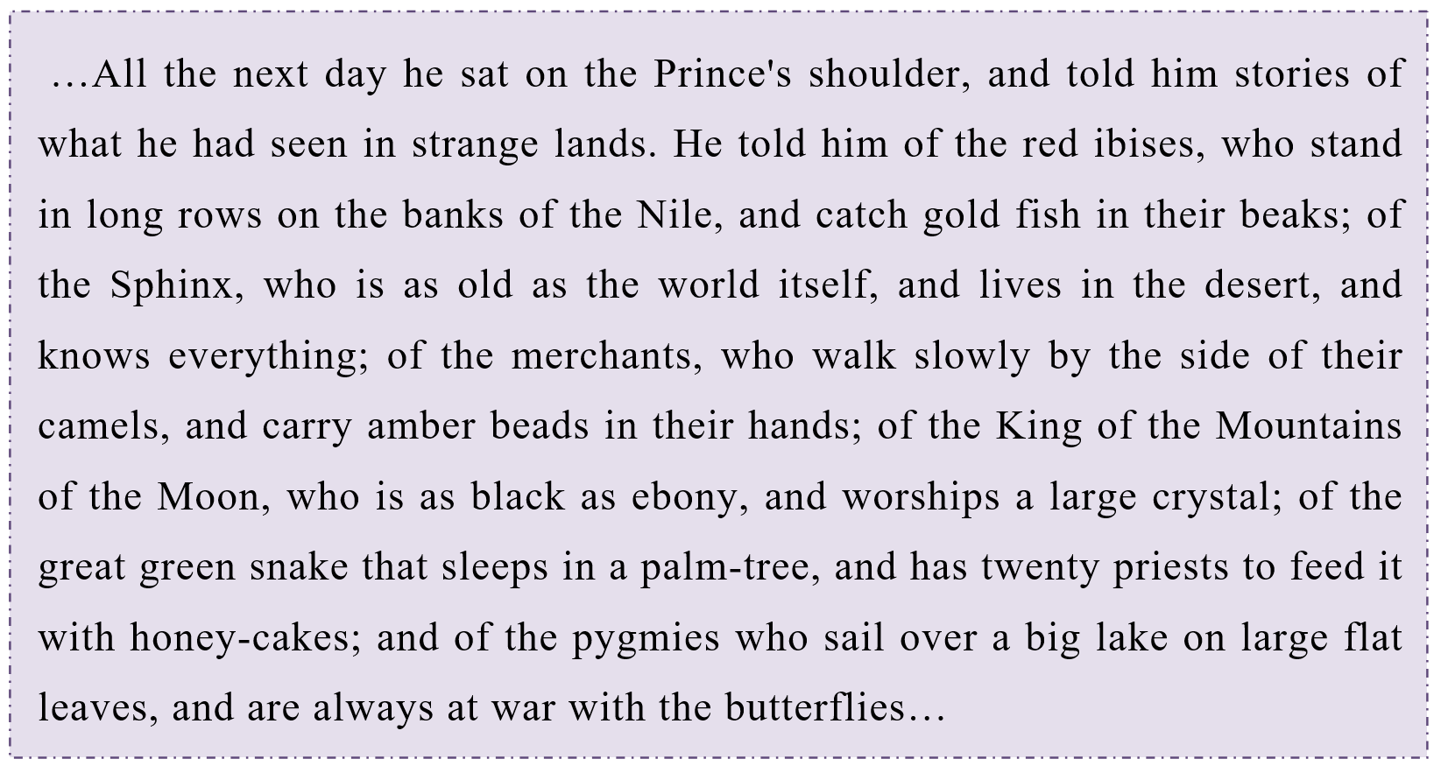
Allegory: __________________________________________
…: _______________________________________________
P.S. Wilde’s epithets give a brilliant colour and wonderful witticism to his plays. With the help of epithets Wilde’s heroes are more interesting, their speech is more emotive; they involve the reader in their reality, in their life.

Exercise 6. Make up 2 sentences with each stylistic device. Study the given examples.
Epithet Example: Lips that have lost the note of joy, eyes that are blinded by tears, chill hands and icy heart.
1) _______________________________________________________.
2) _______________________________________________________.
Metaphor Example: I am a ship without a rudder in a night without a star.
1) _______________________________________________________.
2) _______________________________________________________.
Simile Example: The streets looked as if they were made of silver, they were so bright and glistening.
1) _______________________________________________________.
2) _______________________________________________________.
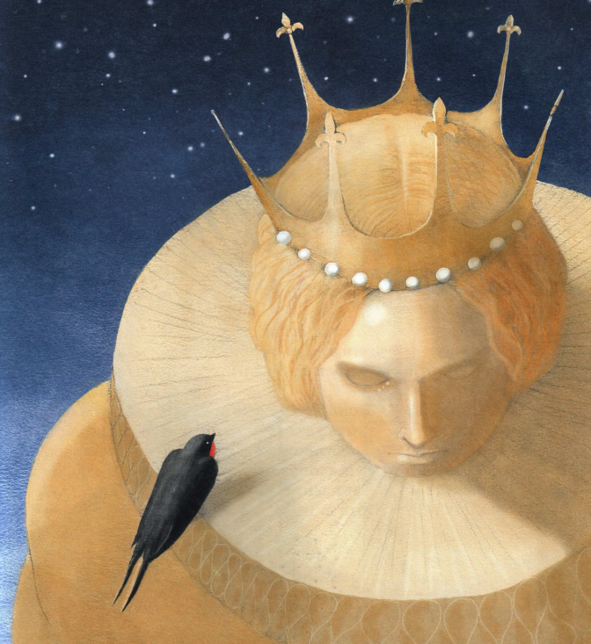
Exercise 7. Read the model dialogue below. Try to make up your own dialogue using similar stylistic devices. A: She looks just like an angel!
B: What are you talking about? There isn’t anyone here. The street is as empty as our wallets.
A: Look at this statue. She is a stone angel without wings.
B: She is definitely beautiful, but too sad. Look, her lips have lost the note of joy and eyes are blinded by tears.
A: Probably, this peerless creature is a symbol of a great loss. But her dead beauty is adorable.

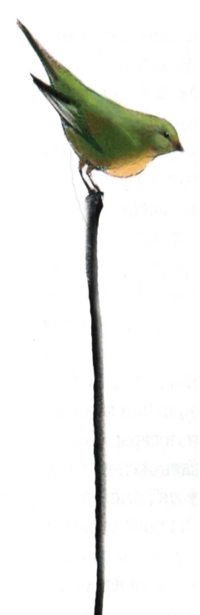
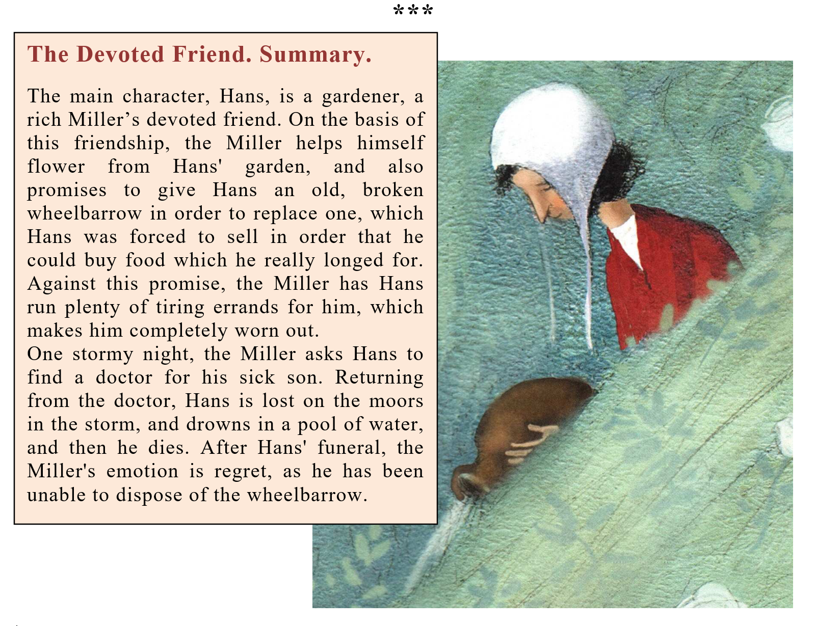
Exercise 8. Translate into Russian (simile and metaphor).
1) “I think that generosity is the essence of friendship”. 2) “Looking just like a lot of yellow canaries”. 3) “Besides, if Hans came here, he might ask me to let him have some flour on credit, and that I could not do. Flour is one thing, friendship is another, and they should not be confused. Why, the words are spelt differently, and mean quite different things. Everybody can see that”. 4) “His tail was like a long bit of black India-rubber”. 5) “The little ducts were swimming about in the pond”. 6) “Looking just like a lot of yellow canaries”. 7) “I am not like the rest of the world”.

