Урок по теме «My family» (5 класс)
Ход урока
1. Организационный момент.
T: Good morning , boys and girls. Good morning dear guests. I’m glad to see you.
T: How are you?
T: What date is today?
T: What day of the week is today?
T: Look at the board. You see circles. Red circle -5. Green- 4. Blue-3. You mark yourselves or your classmates mark you.
• (Рассказать об оценивании –красный-5, зеленый-4, синий-3) На доске ватман с кружками. И на столах коробочки с кружками.
T: On your desks there are sheets with numbers 1 and 2. And you see a stair of success. (лестница успеха)
- (Рассказать о том ,что на столах лежат карточки с номерами и лестница успеха на доске и картинки мальчиков и девочек)
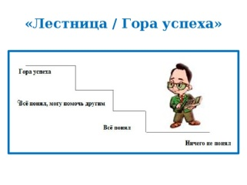
T: I want you choose a leader of your group.
• (Выбрать лидера команды и лидер имеет право оценивать членов своей группы кружечками из коробочки)

T: Today we have a magic box. Guess a riddle
- We use it when we listen music going to school? Travelling by train, by plane. (headphones) Listening
- We use it at school, you put it in your schoolbag, (a bag) Reading
- Speaking
- We use it in every lesson, when we want it write an ex. (a pen) Writing
T: Look at the slide and choose the expressions which united with our lesson.

read the text
go for a walk
listen the exercises
dance
write the words
speak French
speak English

(Презентация , слайд 1)
2.Определение темы урока
T: Look at the board and try to guess the topic of our lesson and what we are going to talk about. (фильм 1 «Один дома»)

T: The topic of our lesson is “My family”

3. Лексическая зарядка. Отработка слов (видео 2 «Слова Семья»)
T: Look at the screen and repeat all together

4.Тренировка орфографических и лексических навыков.
T: Ok. You have done it well. But we have got another task.
a)Please, look. You should JOIN THE PARTS OF THE WORDS
MO TER BRO CLE
FAT THER NT MOTHER
SIS HER AU THER
FA TER UN WI
DAUGH MILY GRAND FE
Соотнести названия с картинками на доске
Лидер оценивает.
5. Отработка лексического материала по теме «Семья»
T: You should guess who they are. (Работа на листочках №1)
ВЗАИМОПРОВЕРКА
my father and my mother are my…(parents)
my mother’s daughter is my … (sister)
my father’s mother is my …(grandmother)
my father’s brother is my …(uncle)
my mother’s sister is my …( aunt)
my aunt’s son is my …(cousin)
the daughter of my brother or a sister is my…(niece)
the son of my brother or a sister is my … (nephew)

T: Check your answers. Look at the board. (презент слайд 2)
Оценивают кружочками, наклеивая на листочки.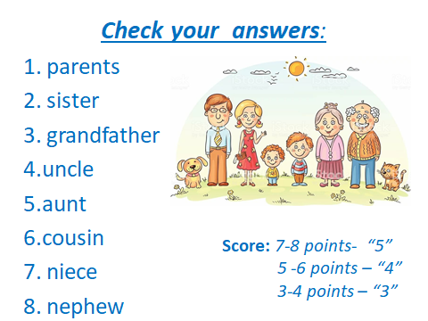

6.Физкультминутка
T: I think that’s time to relax
T: If you have got parents, please, stand up!
If you have got brothers, touch your nose!
If you have got sisters, touch your ears!
If you have got cousins, please, close your eyes!
If you have got grandparents, please, smile!
If you have got aunts and uncles, please, clap your hands!
Hands up! Hands down!
Hands on your hips! Bend left! Bend right!
Stand straight! Please, sit down!
7. Отработка лексических навыков в речи. САМОПРОВЕРКА
T: Take card №2 (Работа с карточкой №2) (видео Две Семьи )

T: Look at the video without sound. What do you think the story is about?
Read and listen to the story and check.
В столбиках «До» и «После» поставьте «+», если вы согласны с утверждением, или « - », если вы не согласны с утверждением.
до | утверждения | после
 | In the first plot, it’s a family.
 | In the second plot, they are friends.
 | In the first plot, they are six in the family.
 | In the second plot, the girl is teaching to swim.
 | In the first plot, they are in a park.
 | In the second plot, they are on the beach.
T: Check your answers yourselves. Look at the slide. (презент слайд 3)
T: Don’t forget to stick circles.
8.Речевая разминка.

T: My dear friends, you are good at English . Answer my questions, please. Be active and speak loudly.
Have you got a mother? What is her name? What is your mother? Is she tall? (short?) What color is her hair? Is her hair dark or fair ? Long or short?
Have you got a father? What is your father’s name?
Have you got a sister? How many sisters have you got?
How old is your sister?
Have you got a brother? What is his name?
What is your family like? Is it big or small?
Do you like your family?
(ученики отвечают на вопросы учителя в быстром темпе)
T: (Лидер может оценить активного ученика группы)

9.Письменная работа T: Take card №3 (Работа с карточкой №3)
(Описание семьи по кругу)
T: Look at the board ( презент слайд 4 «Фото Семьи») Describe the photo one by one using the plan. I’ give you only one sheet.

T: After finishing the work the leader of each group reads your story. (Лидер группы выходит и читает свой рассказ. Оценивают.)
10. Домашнее задание. (Презент слайд№ 5)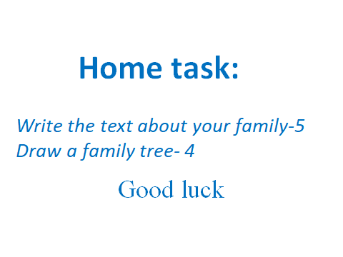

11. Рефлексия
T: It was interesting to know about your families. I’d like to thank you for good work at the lesson. I think you can tell your British friends about your family Did you like the lesson? What did we do at the lesson. I give excellent marks to …, good – to …, etc.

T: Take pictures of boys and girls. (Лестница успеха) (Учащиеся наклеивают на Лестницу успеха мальчиков и девочек)

