Тема урока: «Значение цвета в жизни человека»
Урок предназначен для 9-11 классов общеобразовательных учреждений и школ с углубленным изучением иностранных языков.
Авторы урока: Фролова Ю.В., Ян М.А.
Цель урока: раскрытие значения цвета в жизни человека.
- Воспитательные: воспитание интереса и положительного отношения к изучению культуры англоязычных стран, осознание своей культуры через контекст культур англоязычных стран, формирование интереса к чтению и развитию кругозора.
- Развивающие: развитие способностей к анализу, сравнению, догадке, формированию выводов из прочитанного.
- Учебные: формирование лексических навыков по теме «Цвета», активизация лексических единиц (прилагательные, описывающие черты характера человека), определение идиоматических выражений, развитие навыков высказывания на основе прочитанного, обсуждение текста с переносом на личный опыт.

1. Вступительное слово
Good morning, dear students. Nice to meet you! Today we have a special day, because there are some guests at our lesson. Let me introduce them first…
Вводные вопросы:

1) What is weather like today?
2) How are you?
3) Are you in good mood?
Choose any person in our group, ask your own question.
Now I see that everything is all right, so let's start.

2. Определение темы урока
Let's have a look at the screen. Here you can see some beautiful pictures. Your task will be to guess what are we going to speak about today. How do you think, what is the objective of our lesson? Any variants? You are absolutely right-we are going to speak about colours. It is an open secret, that the world around us is different and colourful. Colour is a mysterious phenomenon and it has a special meaning.

3. Вопросы по теме
Now have a look at the screen. There are some questions for you to answer.
1) Have you ever thought about the meaning of colours?
2) What role do the colours play in our life?
3) What can colour tell us about a person?
4) What preferences do you have?
На экране появляется картинка с различными цветами и идиоматическими выражениями.
How do you think what will be the plan of our lesson?
I suggest we should work on the following plan:
1) First of all, we will try to understand the meaning of the colours.
2) Further, we will refresh your knowledge about adjectives describing characters of people in connection with colours.
3) The following stage of the lesson is an attempt to connect two definitions- colours and idioms.
4) In the final part of our lesson we will try to make up the conclusion about the role of colours in our life.
Do you have anything against it?
Here you can see different camomiles with colours - black, brown, purple, yellow, green, red, blue, white. Your task will be to choose only one colour. Try to explain your choice, give some arguments.
Идет объяснение значение цвета.
Black - People who choose black as their favourite colour are often artistic and sensitive. While these people aren't introverts, they are careful with the details of their lives and do not share easily with others.
White - People who like white are often organized and logical and don't have a great deal of clutter (disorder, untidiness) in their lives.
Red - Those who love red live life to the fullest and are tenacious (цепкий/ упорный) and determined.
Blue - If blue is your favorite color you love harmony, you are reliable, sensitive and always make an effort to think of others. You like to keep things clean and tidy and feel that stability is the most important aspect in life.
Green - Those who love the color green are often loyal and frank. Green lovers are also aware of what others think of them and consider their reputation very important.
Yellow - You enjoy learning and sharing your knowledge with others. Finding happiness comes easy to you and others would compare you to the sunshine.
Purple - You are artistic and unique. You have a great respect for people but sometimes can be arrogant (высокомерный).
Brown - You are a good friend and try your hardest to be reliable and dependable. Flashy objects are not something you desire; you just want a stable life.
From this experiment, you can get some more information about your personality.
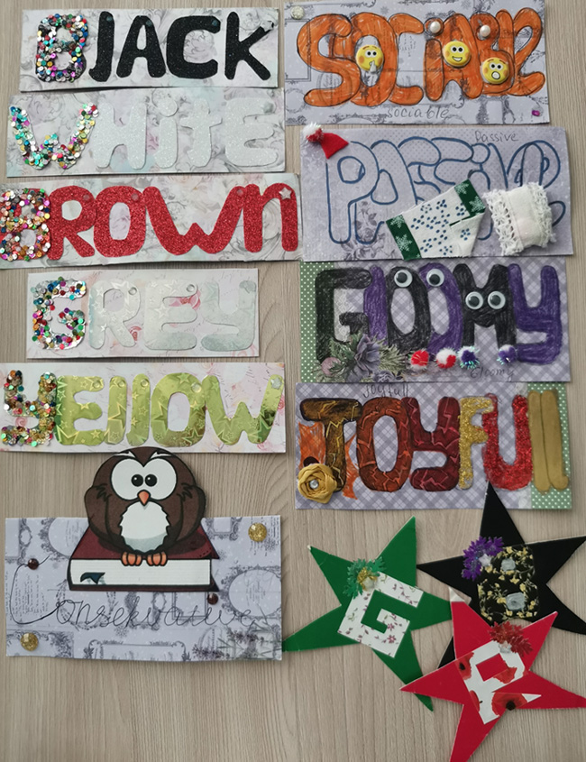

4. Проверка домашнего задания
Лексический диктант по прилагательным, обозначающим черты характера человека.
- Adventurous
- Talented
- Sensible
- Sensitive
- Brave
- Determined
- Reliable
- Independent
- Stubborn
- Ambitious
- Optimistic
- Pessimistic
- Confident

5. Активизация лексических единиц по данной теме
On the blackboard you can see some adjectives, which can characterize a person, and also some colours. Your task will be to match them. I hope, that music will help you. Put on a thinking cap.
Во время выполнения задания играет музыка (вальс И.П.Чайковского «Вальс цветов»)
- Joyful - yellow
- Sociable - red
- Conservative - brown
- Passive - grey
- Tidy - white
- Gloomy - black
Do you know, who is the composer of this waltz? P. I. Chaikovsky is our famous Russian composer, whose music we can listen to entirely. This masterpiece of music is called «Waltz of flowers».

6. Просмотр видео материала по данной теме и ответы на вопросы
Ссылка: https://www.ted.com/talks/neil_harbisson_i_listen_to_color
Needless to say that, it is very difficult to live, if you do not see colours. Unfortunately, some people do not have any chance to realize, how beautiful our world is. The reason is that they have colour-blindness.
Вопросы к фильму:
1) What questions can you ask about the film? What are you interested in?
2) Why do you think this man decided to wear an electronic eye? Was it an attempt to adopt in our world?
3) How did his life change after he had put on this device?
4) Should our government help such people?
5) Have you ever met people who have colour-blindness? Did you help them?

7. «Путешествие в страну идиоматических выражений английского языка»
Now we are in a hurry - we cannot loose time. Let's imagine that we are in the country of coloured idioms. There are a lot of citizens in this country. They are very mysterious and it is difficult sometimes to understand them. But first of all, we can repeat idioms not to lose our way in the country.
Task 1
You see some pictures on the blackboard. Try to match these idioms with the pictures according to the sense.
- To give a black look.
- Once in a blue moon.
- To be (feel) blue.
- To be like a red rag to a bull.
- A white elephant.
- To be yellow (быть трусом).
Task 2
Read the sentences and then say which of the idioms you can use in the sentences below.
- My daddy has a car, but he doesn't drive and he has no garage.
- Jack is not brave at all, he always runs away, when we fight.
- My aunt Polly can't stand long hair and platform shoes.
- I think he hates me. He always looks at me angrily.
- What has happened? Why are you so sad?
- Call me more often. You hardly ever call me these days.
Task 3
Let's finish the sentences with idioms according to the context.
- Jack is a very brave person. He doesn't let offend girls. He has never ....
- Do you often visit your relatives? Unfortunately, not. They live in the Far East, that's why I do it only ... .
- - Why are you so unhappy today?
- Don't mind, please. I'm just....
- My new young man is very rich. He gave me a statue of horse as a birthday present yesterday.
- But don't you think, it is a real....
- I have broken a very expensive cup today, but my mother didn't say a word to me, she just....
- You must switch off your mobile telephones during the lecture, because they are ... .
Task 4
Do you know any other English idioms in which colours are mentioned? Now we are ready to get acquainted with the citizens of this city. Let's read information about them. But our task is not only to read about them, but we must choose the most appealing person from your point of view to be our guide of the city.

8. Драматизация
Lady Red.
This young lady is considered to be the most fascinating girl in the city. Her cherry-red lips, red hair drove mad lots of young gentlemen. But she is a strong person: rather hot-tempered and red-blooded. The word "must" to her is like a red rag to a bull.
Mrs Yellow.
She is rather famous, but she also writes for the yellow press from time to time. Some of her scandal stories were a real sensation. As for her character - she is yellow. But on the whole, she is a rather pleasant woman.
Professor White.
Professor White is the most respectable man in the whole country. He is a short man with white hair. He is very experienced and knows black from white. He hasn't got much money, that's why he doesn't like when somebody gives him a white elephant.
Mrs Blue.
Mrs Blue is one of the richest persons in the city. She is blue blood and very proud of this fact. Some people say that she is a blue stocking. Her hobby is to gossip, that's why she talks blue over the telephone. She doesn't like to work, that's why she visits her work once in a blue moon. As she explains it to her boss, she fells blue.
Dr. Black.
Dr. Black is a well-known scientist. His clinic is famous all over the world. He is said to deal with black magic. He often says: "The devil is not so black as he is painted ". But his relatives don't like him at all and often give him a black look.

9. Финальная часть урока
Обобщающие вопросы по уроку:
- What questions did we manage to answer?
- What are we going to do the next lesson?
- What new idioms have you learnt from the lesson?
- Is it important to use idioms in the speech? Why?
- Complete the sentences with the help of the cards.
It was interesting for me…
I found out that…
Nobody will deny that the role of colours is enormous.
Объявление домашнего задания
On the blackboard you can see three quоtations. Your task will be to choоse one of them and to comment on it. Speak as much as possible, but not less two minutes. If it is possible, try to use coloured idioms.
Подведение итогов работы на уроке
You have worked hard today, so as far as your marks are concerned, they are following…

