Учитель: Семененко О.М., МОУ СОШ №1, г.Рыбинск.
Сценарий урока в 10-11 классе по теме: «Семейная жизнь. В чём её важность и проблемы».

Цель урока: развитие умений говорения (монологическая речь), совершенствование речевых навыков и развитие речевых умений на основе прочитанного, развитие социально-культурной образованности учеников.
Дома ученики прочитали текст “Importance of Family Life” с вопросами к нему как домашнее задание. Часть работы на уроке строится на материале этого текста (см. приложение). Ранее ученики работали с ЛГТ Е.И.Пассова (см. приложение).
Ход урока.
- Речевая зарядка - учащиеся зачитывают вопросы, которые лежат на карточках перед ними и отвечают на них.

№ | Вопросы | Ответы
1 | What are the prime functions of a family? | Enculturating and socializing children are two of the prime functions of a family.
2 | What is the role of a family in bringing up children? | Family acts as a security, provides comfort and emotional support, nurturing and the warmth of affection and tenderness. Family bonds help to instill trust and hope in the world around us and belief in ourselves.
3 | What does a family build up?/ teach children?/help children do? | A family builds up a person’s personality, teaches him moral values and often helps choose his/her career path.
4 | What does a family determine? | The family determines to a large extent the social roles that the children will perform.
5 | What does a family prepare us for? | Our family molds us, prepares us for what we will experience in the world and how we react to those experiences.
6 | What do goals a person sets for himself in life depend on? | The goals a person sets for him/herself jn life are very much dependent on the family life.
7 | What does the Family life give a person? | …self-confidence and strength, success in life.
8 | What traits do happy families have in common? | Communication, togetherness, sharing activities, affection, support, acceptance, commitment, resilience are typical in families that function well.
9 | Why are families like a team? | Each individual family member brings skill, personality and role to the family team, just as each sports player has a specific position in the team. As a family team, we can help each other get through tough times. We have family teamwork.

10 | Why are family values important? What do they determine? | Family values express fundamental beliefs about what and who is important, how relationships should be fostered, what is the place of money and power. Values determine behaviour and give meaning to everyday life.
11 | How can family bonds be strengthened? | Family bonds can be strengthened through family rituals.
12 | What is one of the simpliest and most effective family rituals? | One of the simplest and most effective family rituals is sharing meals.
13 | How can shared mealtimes benefit families/children? | They can increase children’s sense of belonging and stability. Children who share meals with their families on a regular basis tend to eat healthier foods than those who do not. They are less likely to be depressed or use drugs, less likely to be violent and experience emotional stress. They are likely to be more highly motivated in school and have better peer relationships.
14 | Other useful family rituals. | …

- Беседа учителя с классом.
- What problems do modern families face?
Предполагаемые ответы:
- Generation gap
- Poor communication/lack of communication
- Lack of money/time
- Lack of common interests/common activities
- Etc.

- What are the reasons of the generation gap?
- How does it reveal?
- What should/shouldn’t be done?
- What kind of relations must be in the family?
В ответах учащиеся используют материал из ранее изучавшейся ЛГТ/ таблицы «Generation gap», авт. Е.И. Пассов.
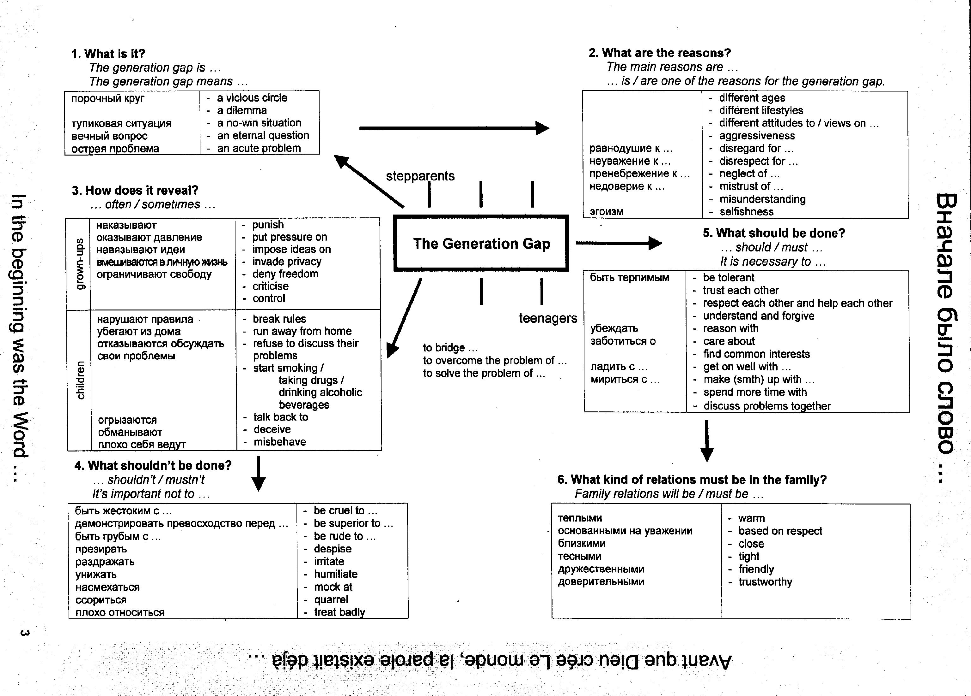

- Развитие навыков устной монологической речи.
Задание: What is the role of your family in your life? What are your family traditions?
- Работа в парах.
- Ответы двух-трёх учеников перед классом.

- Развитие навыков устной монологической речи.
Задание: comment of the following statements. Give your arguments for/and/against this idea.
- To bring up a child one should be strict.
- There should be one child in a family.
- It is important to share responsibilities in a family.

- Работа в 3-х группах.
- Выступление докладчиков групп. Участники других групп дополняют (с аргументами), высказывают своё мнение.

- Развитие умений ознакомительного и изучающего чтения.
- Чтение текста “Wife abuse” учащимися.
- Ответы на вопросы после текста (в группах, по цепочке).

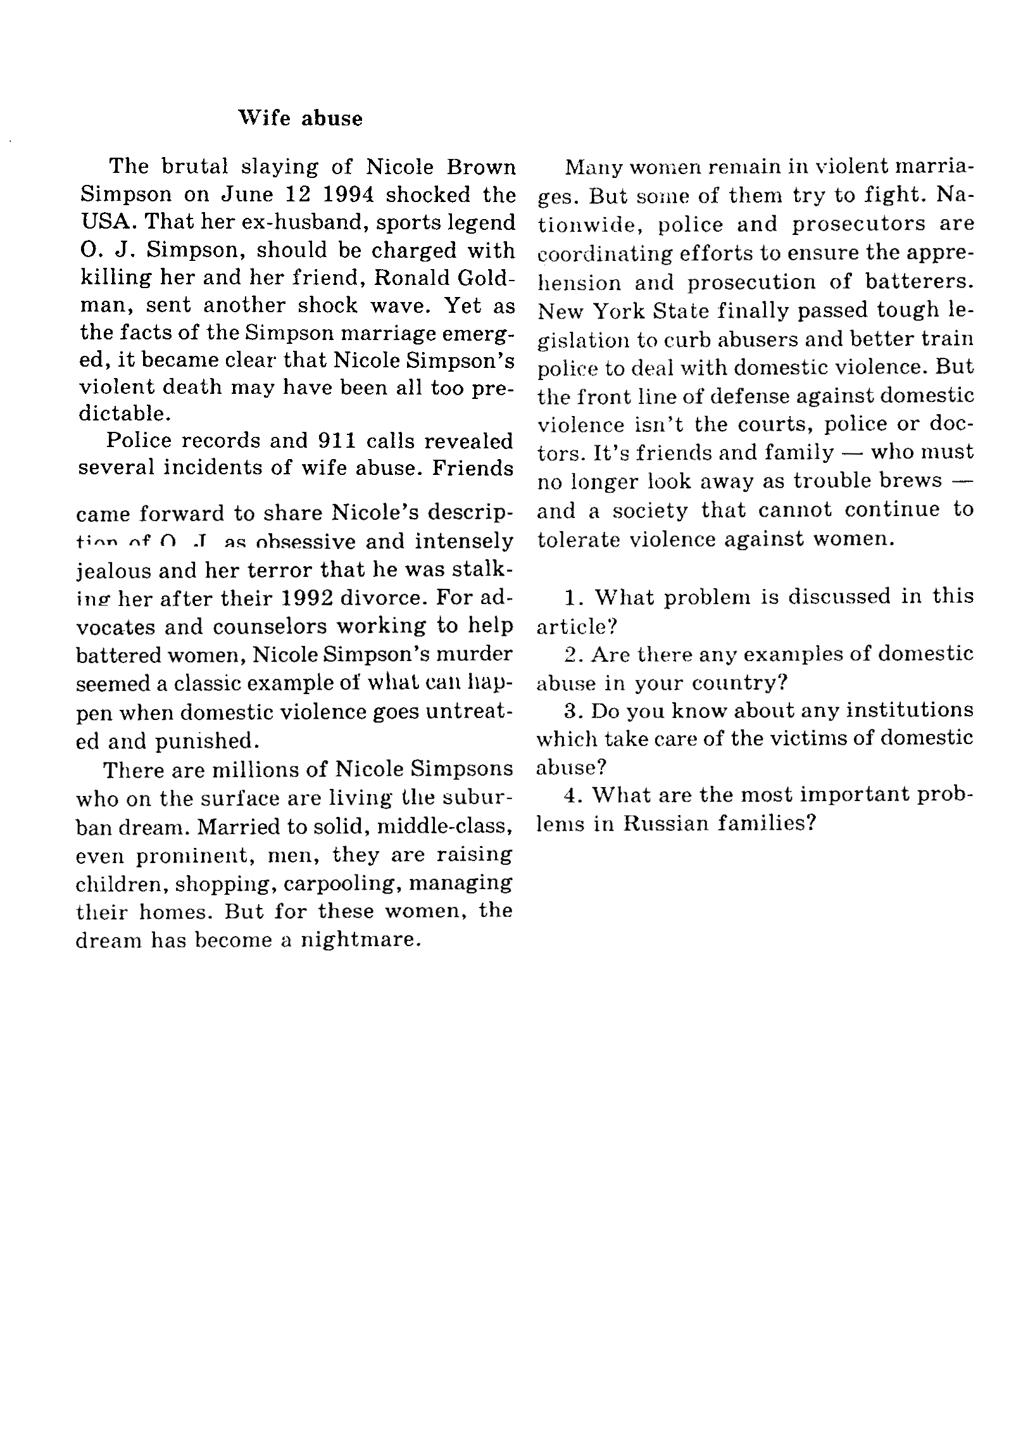
- Домашнее задание.
Перед вами два письма в журнал. Выберите одно из них и ответьте (как психолог) на него: как бы вы поступили в данных условиях.

Приложение.


